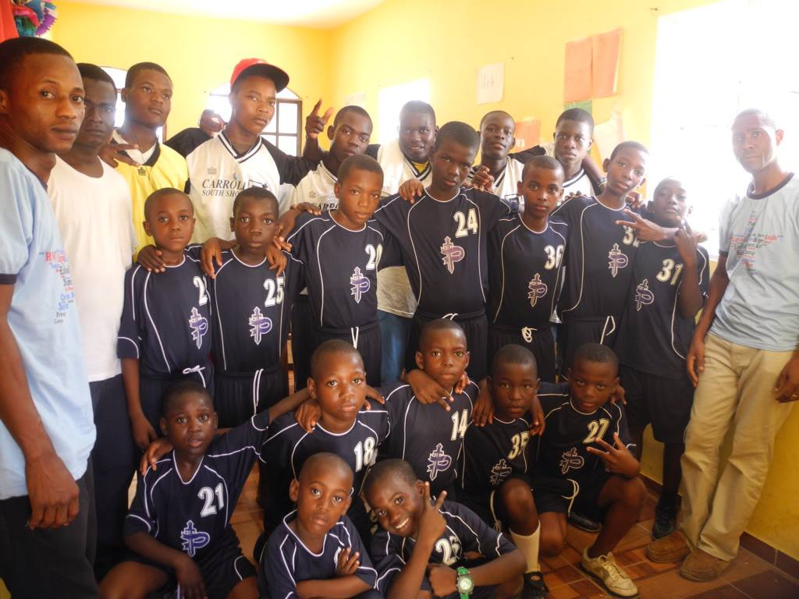

Wyclef,

We came to visit you today. Can you please come visit us before you leave?

We hope so!

www.EsperanzaMeansHope.org
CaitlinMcHale@EsperanzaMeansHope.org
809-361-8193
809-970-7257

