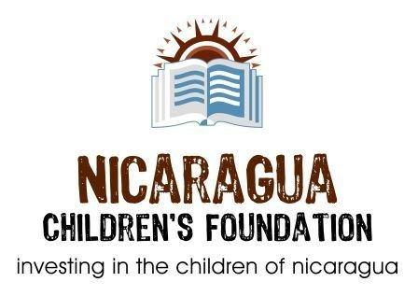
Oliver's Story-Chapter Two

If you've made it up to the second floor of Veronica's Spanish School, you have likely already met Oliver. He is in a wheelchair because he fell out of a mango tree when he was 12 years old. Oliver has graduated from a Business Administration program at the university in Rivas and now works for the Nicaragua Children's Foundation.
Recently, Oliver was advised by a doctor that he may have a chance to walk again. The first step was for him to have an MRI exam, which costs about $1,000 in Nicaragua. With the help of generous students of Veronica's School, we were able to raise sufficient funds for the MRI to take place. The results of this test produced good news and bad news. The good news is that Oliver is eligible for an operation that could potentially restore his ability to walk. The bad news is that the cost is approximately $10,000.
Oliver saw this as an insurmountable hurdle; we don't agree. While the NCF can't pay for this cost as it is outside of our mandate (and our Canadian Govt. Wouldn't like that), we hope that together we can all contribute to make Oliver's dream a reality. Our family will start the ball rolling by contributing $500. Please join us by contributing whatever amount you are comfortable with, large or small, and together we can make this happen.
Thanks very much,

Mona and Allan Donovan
Nicaragua Children's Foundation

