Case Study of Nooroz:
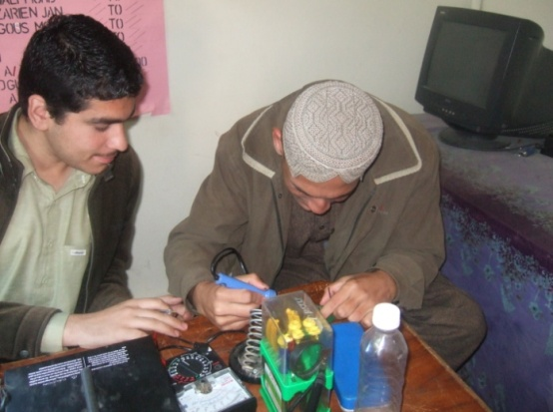
Nooroz age 18 is residing in Mohammad khan street Quetta. He is attending CPC activities regularly since 2009. Child protection center was established 2006 through society for empowering human resource (SEHER) in collaboration with group development and different department linked with child protection our project focused commercial sexual exploitation children.
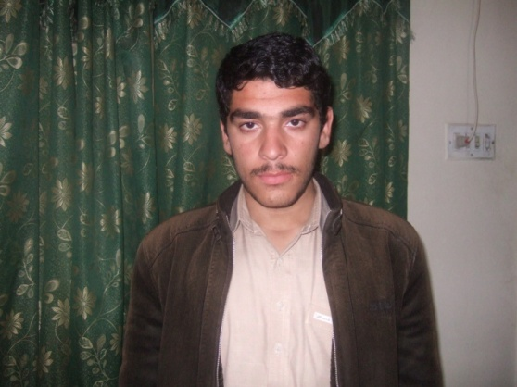
He left the school due to ignorance of the parents and bully from peers, he did not find any support from teachers nor from parents to manage the situation his father spend most of his time out of town for his business activities. So he left the school and was sitting at the spots he spend most of his time in the cinemas, gaming zone, snooker clubs.
Noroz Own Words: I was the resident of village Killa Saif ullah basically I belong to village Killa Saif ullah. I belong to Kakar tribe. Now a days our present address Mohammad Khan Street no. 8 Quetta. I have two brothers and three sisters, my father works as a merchant; he imports dry Fruits from Iran and sells that fruits in Quetta city this is our source of income to fulfill our daily expenses. My mother is house wife she works at home and look after the children. When I was 14 year old my father use to beat me to bring high grades in the school but I was not able to as I did not get any support from teachers in the school on but I dislike my schooling system and teacher’s behavior and punishment I was facing. My peers bully me which was very stress full for me, to overcome this stress I start going to the spots and taking interest in the bad company of the friends I had at the spots, CPC mobilize saw me at the spot and talked to me very politely and with consoling sentences. Mr Javed mobilize and aware me about child protection center. I registered since 2009 through Mr. Javed when I came in this center I learned more things beyond the imagination and this is joyful learning since at that time till now different activities like a English language, computer class and specially I learnt mobile repairing skill class it is very good for me and I am professionally utilize this skill as a skill trainer in CPC.
I have spent great time in this center as a learner and I enjoyed in this center it provided different recreational activities and educational session and develop my skills as a professionally and personally. It is great achievement for me when I complete my learning process now I become a Skill Trainer in CPC. I am very thankful to SEHER organization. Now my vision is that I want to complete my education and now I want to improve myself and work on my age fellows and friends on context of exploitation and it’s my wish that my friend and age fellows start learning in friendly atmosphere under my guide learning.

