KIRTIPUR PLASTIC SURGERY & BURN CENTER

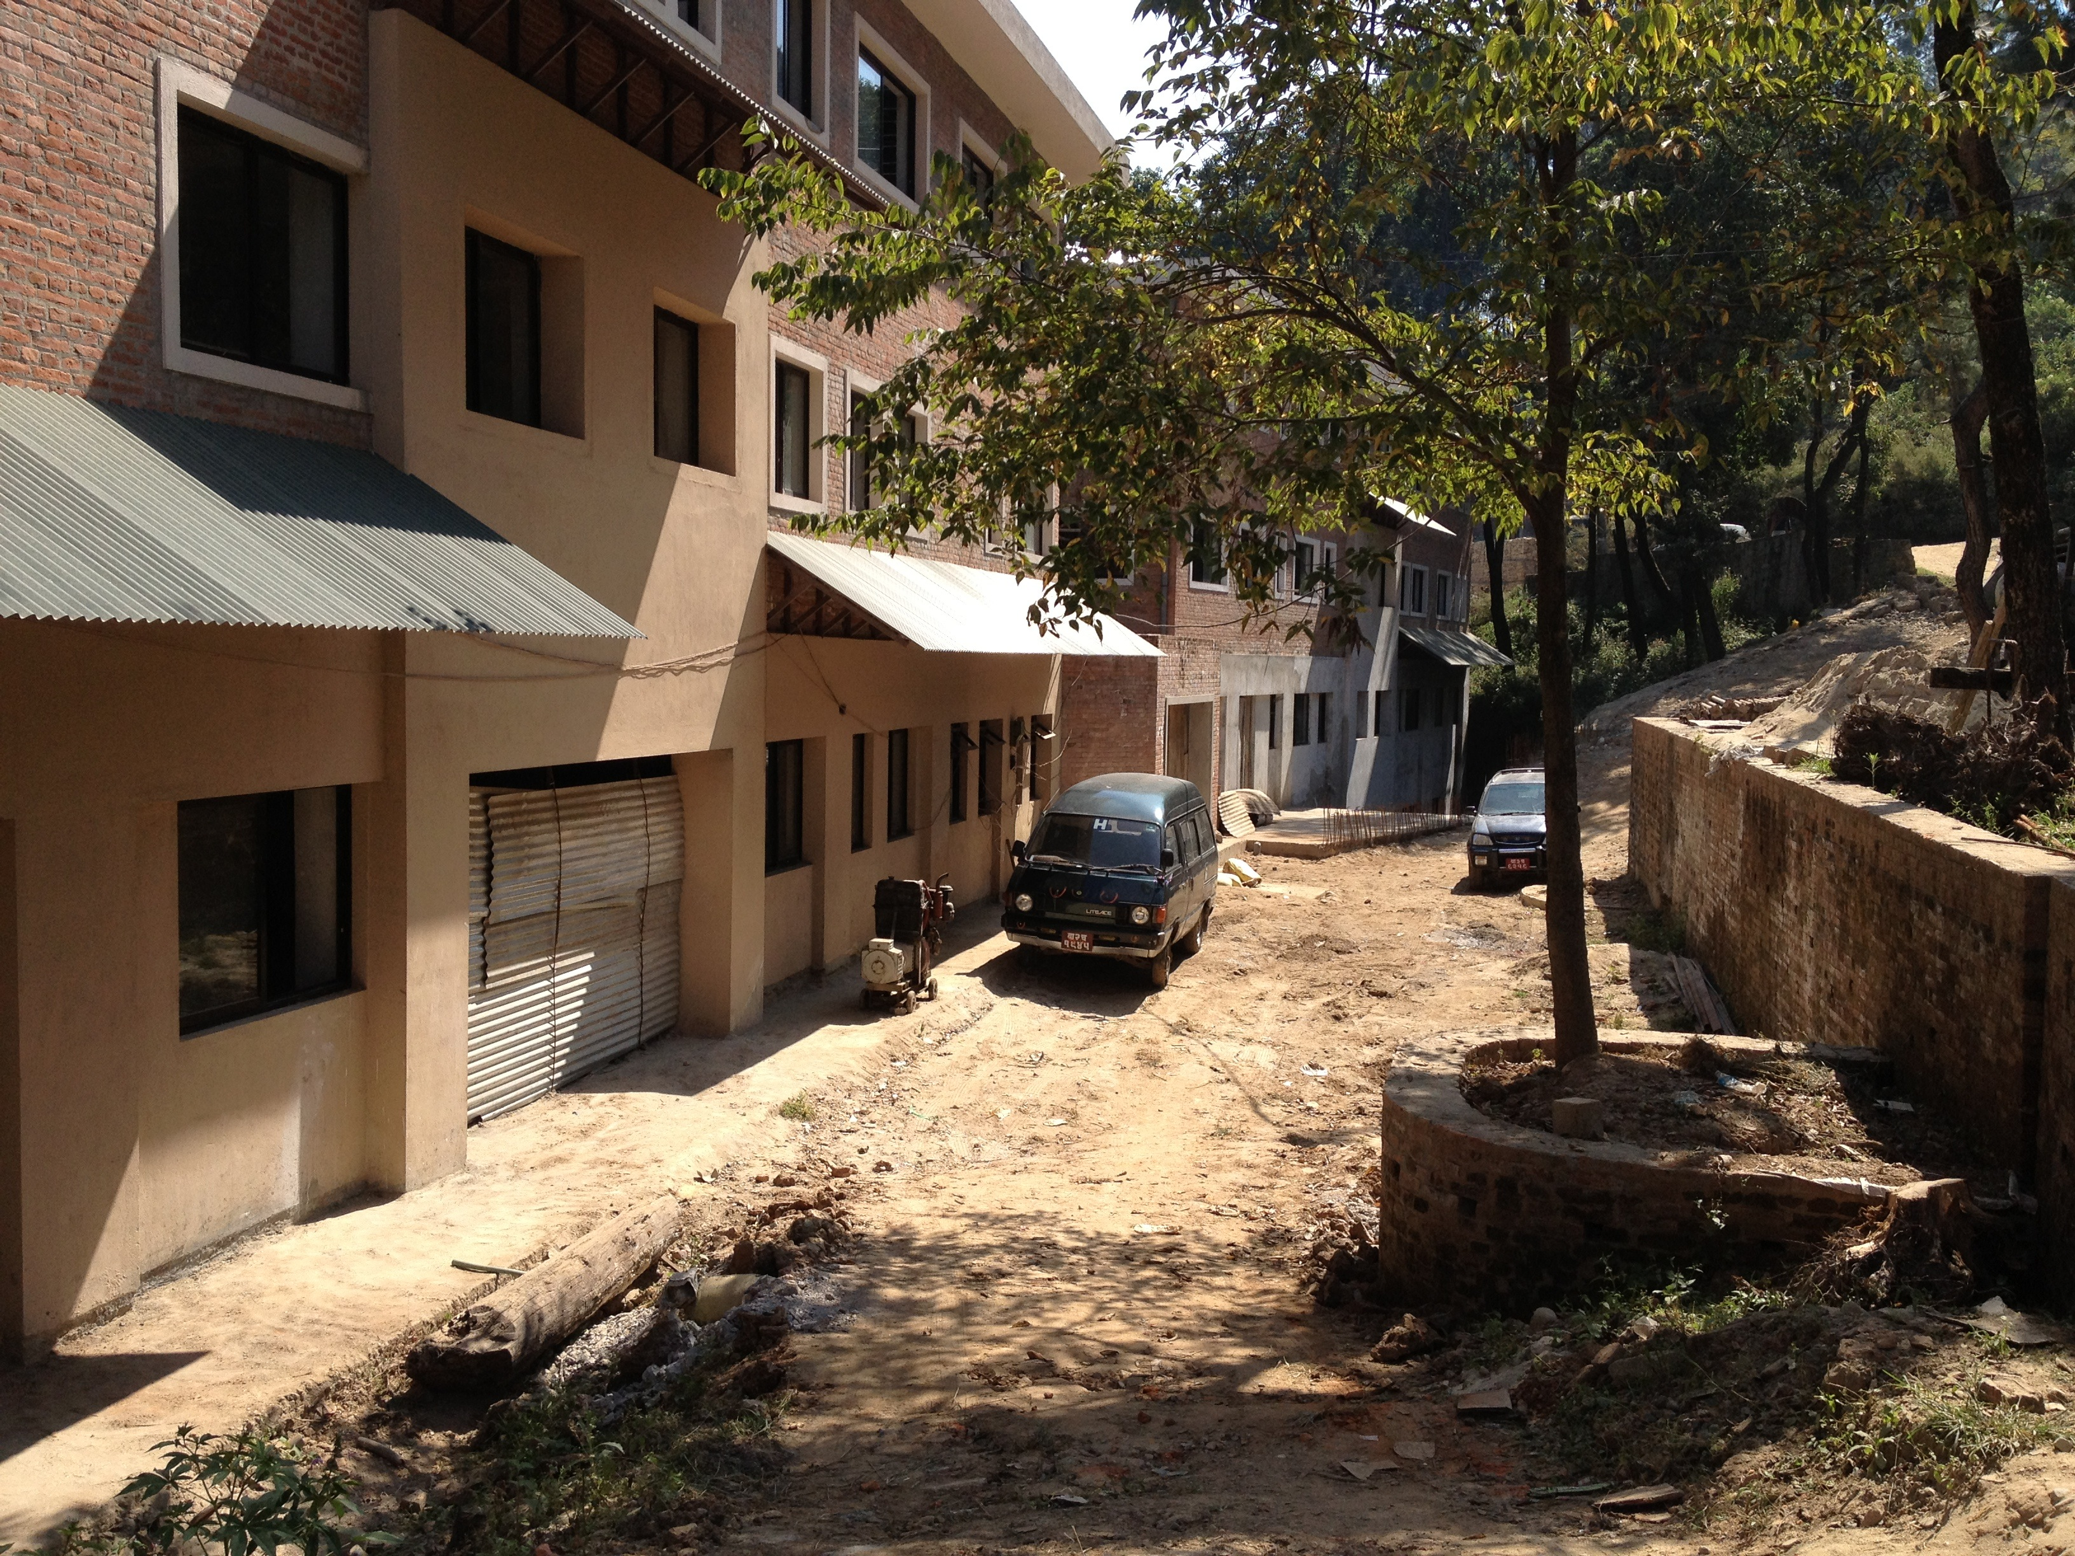

CAFETERIA PROJECT / Social Business

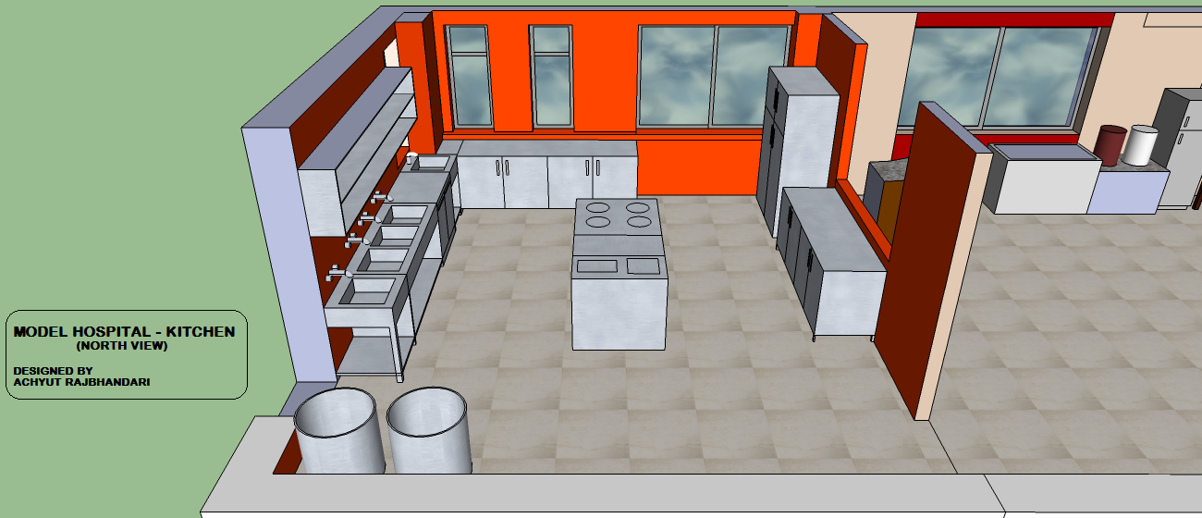

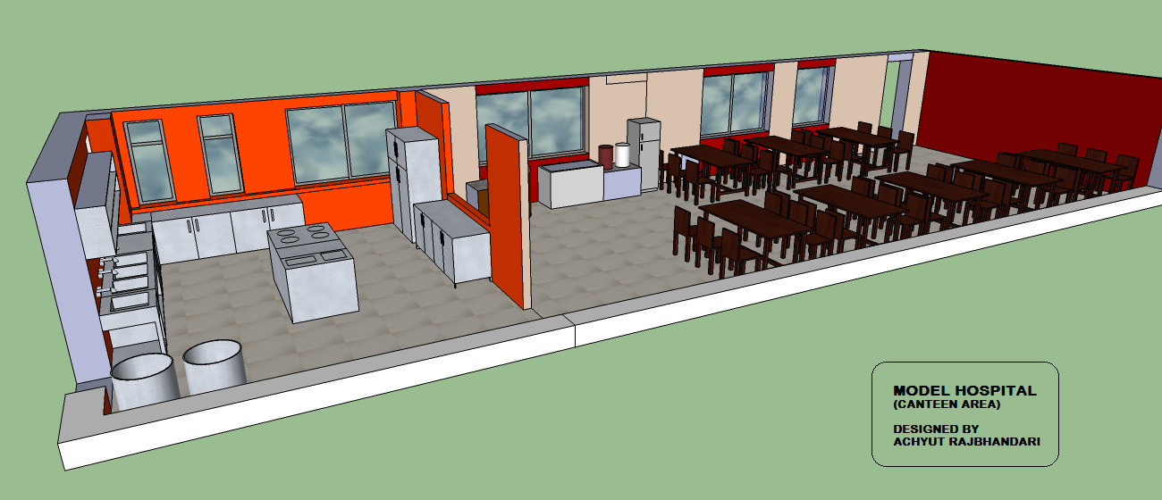

Designed to provide meals for patients, staff, guests, families and visitors with all proceeds dedicated to care of indigent burn victims.