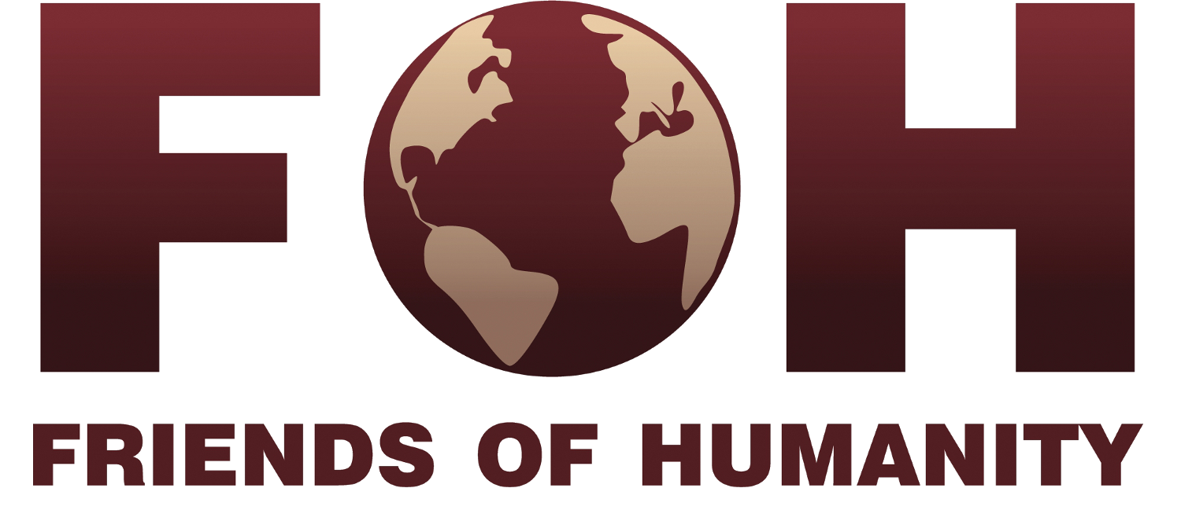

Monitoring & Evaluation Report – 2011
Report #1

Mongolia; Lamp of the Path
Ulaanbataar, Mongolia

Schedule

1. March 2012 – first evaluation report to be sent

2. August 2012 – first evaluation report to be completed and returned

Rest of schedule is to be determined depending on timeline of the project. An updated schedule will be sent with the next Monitoring & Evaluation Report when more information is known about the timeline of the project.

Please send questions and completed reports to:

Nicolas Sion
Administration, Communication and Project Management
1211 Geneva 21 / Switzerland
+41 (0) 22 732 77 83
contact@friendsofhumanity.ch

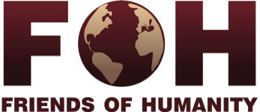

Monitoring and Evaluation

Friends of Humanity is hoping to improve the effectiveness of the projects it sponsors and would like to invite its partners to help with its new Monitoring & Evaluation system. This process will have two parts:

- Quantitative indicators (including budget)
- Qualitative indicators

Staff members and community members should be involved in the process.

We know that you may have previously provided some of this information, but we would like to see how projects are following up on their initial plans and budgets – the most up-to-date information would be greatly appreciated.
.
Important: please click on each field box to type in responses.

Form completed by (name & position): David Szeto, Director, Lamp of the Path

Note: In addition to completing this form, please send us an expected timeline for the remainder of the project.

Quantitative Indicators

Project Information

Number of participants using soup kitchen: 70
Age of participants: 0-10 years old – 11-20 years old –
21-30 years old – 31-40 years old –
41-50 years old – 55 50+ years old – 15
Number of male participants: 40 Number of female participants: 30
Are there any costs to the participant? What costs? nil

Staff

Number of on-site staff members: 2
Number of off-site staff members: nil

Budget

Lamp of the Path’s original budget for the soup kitchen was projected to be 24,963USD, and as FOH has provided only 8,860USD (8,000CHF), please indicate any changes to the budget as a result, or send an updated budget worksheet if that is more convenient.

Additional budget amount (non-FOH): $2500.00
What are these additional sources of funding? From local Mongolians in cash and food staff and from individual sponsors in Singapore, the yearly budgetary requirements remain as projected earlier.

Qualitative Indicators

Questions for Lamp of the Path staff members

For the following questions, please interview staff members for their responses (yourself included!) and provide justification for your answers. The purpose of this section is to get a sense of the project’s administration. Feel free to use as much space as necessary – the more information you can provide us with, the better!

- Is the soup kitchen or any of Lamp of the Path’s projects addressing the long-term issue of lack of food and homelessness?
Yes, as long as there are old, sick and/or vulnerable people

- Are there any plans for expansion to serve a larger number of people?
Yes, we are planning to begin an outreach program to deliver food to those who can't come to the Community Center. And also, later on, to purchase a neighboring house to be remodeled as a hostel for the homeless.

- FOH funding is projected to last for five months; is there a plan for funding beyond that period?
We have local fund rasing activities and also internationally through the website. But results are way below what is needed. We hope in a new installment from FOH which will bring us to the end of the year.

- Are any locals involved in the maintenance and staffing of the soup kitchen?
Besides the director, all the other staff are local. If we get funding for the outreach activity, we will hire a couple of local staff, of top of what we have already.

- What is the organization’s relationship with the local authorities?
We have a very good relationship with the Bayanzurkh District of Ulaanbaatar. The district issues the Soup Kitchen license and they make a physical inspection once a year.

Questions for participants and community members

For the following questions, please interview local community members and students in the school. The purpose of this section is to provide some insight into the community’s overall perceptions of the project and the role it plays in local life. Note: some questions may be repeated from the previous section (that means we want to know what everyone thinks!).

- What is the community’s perception of the soup kitchen?
The community is very supportive of the Soup Kitchen, especially of course the beneficiaries who not only receive free food, but also free medical care by our other project, the free Health Clinic.

- Are any locals involved in the maintenance and staffing of the soup kitchen?
Yes, 2 Mogolians

- Are local resources utilized for daily soup kitchen operations (food, ingredients, materials etc.)?
Everything is purchased locally, from the local market. Food purchases are made once a week

- In what ways has the soup kitchen positively impacted the community as a whole?
Providing a hot lunch for the poor and homeless, daily. Over 20,000 meals have been served during the last year.

