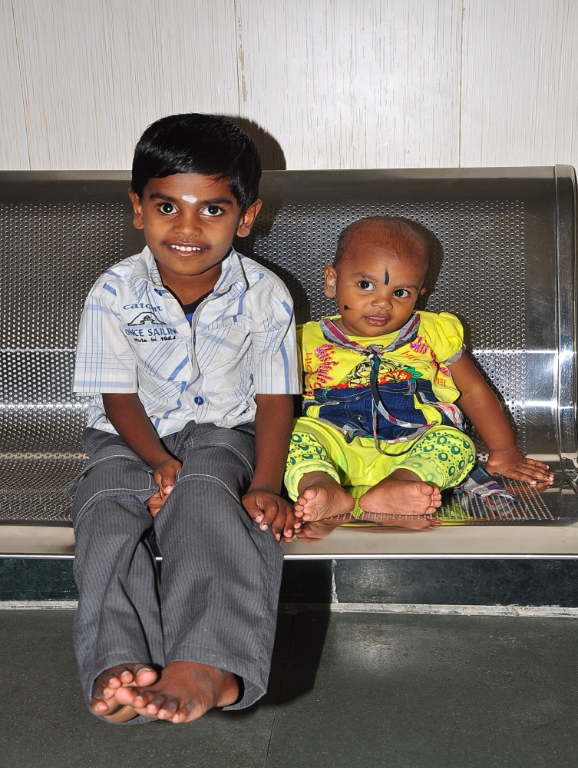
Rithikasri (age 2) and her big brother Diwakar, both survivors of inherited Retinoblastoma, thanks to arly detection and treatment at Aravind Eye Hospital – Madurai, India.

