Centre for Women's Development and Research

Skill Training for 250 Tsunami Affected Women

Updates Report April 2006

It is almost fifteen months have gone after the devastating Tsunami disaster. But it is heartening to see people rebuilding their lives and returning to normalcy. Women themselves have proven that they have an important role in disaster management and rebuilding families. We are happy that we are part of this process of rebuilding with support from GlobalGivings. The income generation skill trainings also served as psychosocial counseling process because learning a new skill and thinking about future gave them lot of hope and confidence.
We have started our trainings during August that is immediately after receiving the first grant from Globalgiving. We already have trained nearly 200 women in different income generation skills like 1. Coir rope making, 2. Coconut leaves Thatch roof making, 3. Nursery raising, 4. Handmade paper making 5. Paper bag making, 6. Palm Leaf product making, 7. Mushroom growing 8. Food processing (fruit juice and pickle making) 9. Vermicompost making, 10. Soap making, 11. Incense stick making, 12. Screen printing . Each training lasted 3-5 days in addition to specific skills they also received soft skill trainings. Each group of women were also given a loan amount, each woman received loans from Rs.1000 (US $ 25)- 5000 (US$125). In our earlier report we have mentioned about coir making training, Thatch roof making training and paper bag making training. In addition to that we have also organized a training on "Disaster Preparedness" for women.
Initially these trainings were very helpful for the women to build their confidence and also earn some income in that difficult situation during that time men were not going for fishing, so their income even though small helped their families. We could help 200 families through these women. But once the fishing were started most of the women went back to fish vending. In the villages they use the skills like coir making and thatch roof making, vermicomposte making, nursery raising because they can use the products locally plus they can do this work even during part time. In the city paper bag making, screen printing, incense stick making they could not sustain it because they have to compete in the local market with big firms that means they have to improve the quality and also need additional capital. But the younger women with some education wants to use their new skills. The few days training provided by us and small capital given by us is not enough for that they need additional trainings in Entrepreneurial skills. So now we are planning to provide further training and other services like quality improvement and marketing services. We are looking for further funds for that, more than funds we are looking for suitable volunteers who can help us small production/business units that will produce some goods both for local markets and outside markets, that would provide some employment for women and that units will also serve as training centers.
By helping 200 women actually we have helped 200 families, the children in these families are attending the schools, no one dropped out of school, they are also healthy. This is the first time women from fishing community organized themselves as an association and involved in community rebuilding, the men also slowly understanding the importance of women's role in community building.

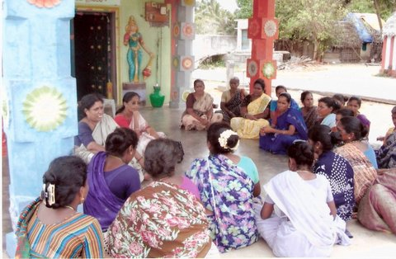
Meeting with women

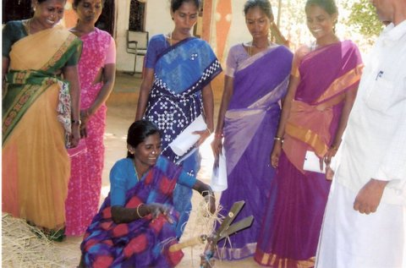

Mushroom growing Training

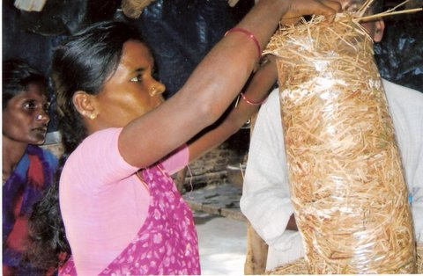

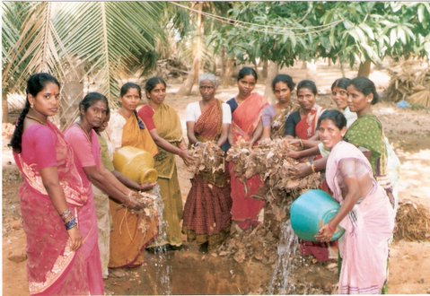

Vermicompost making training

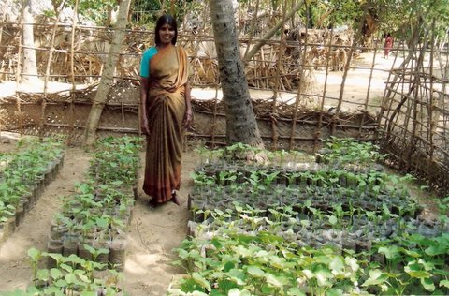

Woman with Jatropa Nursery

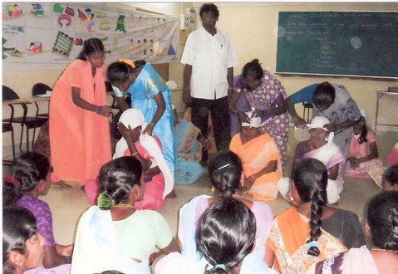

Disaster preparedness training

