Creating a Great Project Page Worksheet
It is time to create a great page for your project! This worksheet will help you develop content for the four main components of your page: title, picture, donation options, and summary.
Donation Options:
Tips:
- Be specific and show impact!
- Include various levels of options
- Write 3-8 options (minimum value: $10)
Example:
- $35 will provide 3 nutritious meals to 126 orphans
- $60 buys a cow to begin a dairy business
- $90 will provide clean water for 50 villages
- $200 will provide livestock for 50 families
- $500 will buy 6500 acres of land

Your project’s donation options:
$_____ _____________________

$_____ _____________________

$_____ _____________________

$_____ _____________________

$_____ _____________________

$_____ _____________________
Project Title:
Tips:
- Keep it short (between 5-10 words)
- Use simple words and avoid acronyms
- Be descriptive (who, how many, and where are your beneficiaries)
Example:
Restore Eyesight to 500 Nepalese Villagers
Your project title:
________________________________

Project Picture:
Tips:
- Use close-up photos of 1-2 individuals
- Choose vibrant and expressive photos
- Keep photos positive (choose smiles)
- Use 5-10 photos (pick one as primary)
Example:

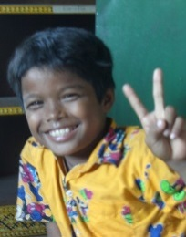

Project Summary:
Tips:
- Keep your summary brief (less than 200 characters)
- Avoid acronyms and jargon
- Be descriptive (What are you doing? How? Where? And for whom?)
Example:
Round Table India plans to build four classrooms to provide free education for girl children who hail from the poorest sections of society in Chennai, also providing the girls with free meals.
Your project summary:
____________________________________________________________________________________________________________________________________________________________________________________________________________________________________________________________________________________________

